Pathlock
Dynamic Access Controls Workshop
Level 5 - F-05
Passenger List Export & No Data Classification
Simple Facilitator Guide
Audience  Pathlock engineers  Workshop facilitators | Main use case  Block downloads of classified sensitive data from SE16.  Allow public reference data downloads. | Participant focus  Create or inspect DAC policies.  Test policy behavior in SAP. | Do not spend time on  Rebuilding BADI, enhancement, transport objects, or base DAC setup during the lab.

Use this guide as a quick reference during delivery. It intentionally keeps only what facilitators and participants need for Level 5.

1. Use case and requirement
Requirement  When a user downloads data from SE16, DAC must check the current table classification and the selected export action. | Control rule  Restricted-PII and Internal-Financial exports are blocked for normal participants. Public data is allowed.
Business value  Stops local copies of passenger/customer/booking data while keeping safe public reference data usable. | Workshop outcome  Participants configure or inspect the sample policy, then verify blocked and allowed downloads in SAP.

Expected behavior
Table | Classification | Participant tries to export | Expected result
SCUSTOM | Restricted-PII | Customer/passenger data | BLOCK
SBOOK | Internal-Financial | Booking data | BLOCK
SCARR | Public | Carrier reference data | ALLOW

Facilitator note: keep the story simple - classification drives the policy decision.

2. What is already preconfigured
Facilitators should verify these items before the workshop. Participants do not need to build these prerequisites live.
Preconfigured item | What to verify
Data attributes | In /APPSDM/ABAC > Functional Configuration > Data Attribute Master: DATA.BUTTON_OK_CODE, DATA.CLASS_LABEL, DATA.TABLE_NAME.
Custom code mapping | In /APPSDM/ABAC > Technical Configuration > Custom Code Implementation: ZBADI_BUTTON_OK_CODE and ZBADI_TABLE_NAME.
BADI implementation | SE18 BADI /APPSDM/DATA_ATTRIBUTES is active and supports runtime attribute collection.
Data classification | /APPSDM/DC maps SCUSTOM to Restricted-PII, SBOOK to Internal-Financial, and SCARR to Public.
Download hook | Enhancement ZENH_IMPL_BLOCK_DOWNLOAD is active at the beginning of /APPSDM/CL_ACCESS_CONTROL=>PROCESS.
Workbench/support objects | Package ZDAC_CONFIG and message class zdac_worshop are available.

Facilitator check  Run the test matrix once before participants join. | Participant instruction  Participants should focus on the policy and testing, not the engineering setup.

3. Preconfigured screens - DAC attributes and custom code
Use these as facilitator reference screenshots. They show the base configuration that makes the participant policy possible.
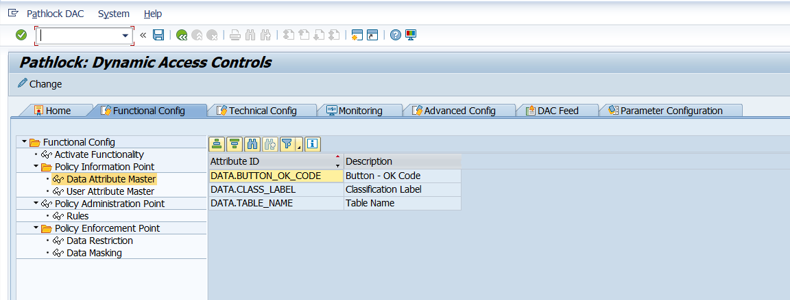  Data Attribute Master: OK code, classification label, and table name | 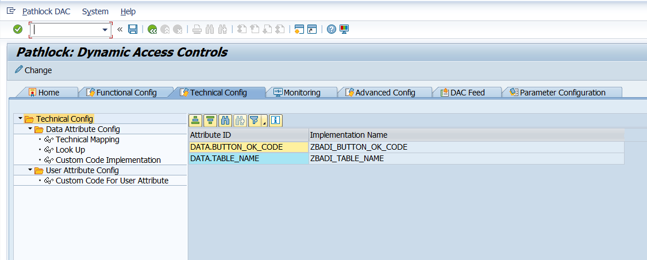  Custom Code Implementation: OK code and table name implementations

Key takeaway  DAC can evaluate both the action the user clicked and the data context of the table. | Participant action  None. These are preconfigured before the lab.

4. Preconfigured screens - BADI, classification, and enhancement
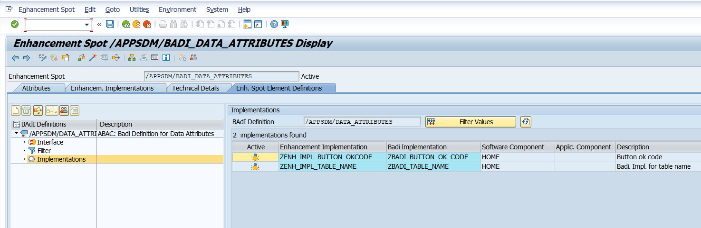  SE18: /APPSDM/DATA_ATTRIBUTES implementation | 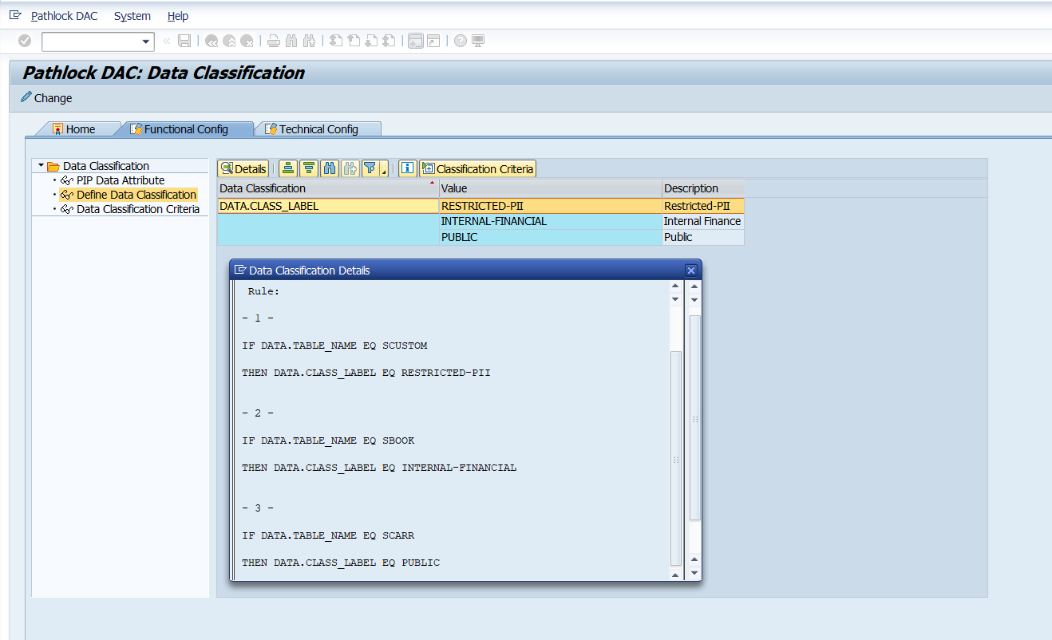  /APPSDM/DC: Classification setup | 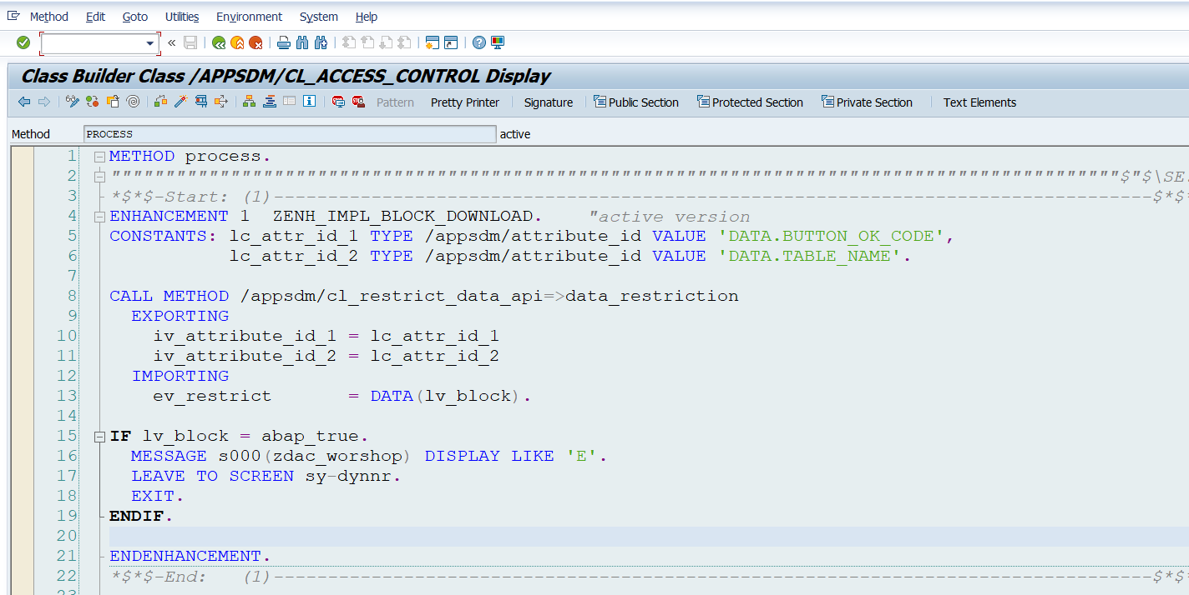  Enhancement: ZENH_IMPL_BLOCK_DOWNLOAD

Component | Simple explanation
BADI | Collects runtime values used by DAC policies.
Classification | Converts table context into labels: Restricted-PII, Internal-Financial, Public.
Enhancement | Calls DAC before the local export is completed and displays the block message if denied.

5. What participants configure or inspect
Participants should configure or inspect the policy, enable the right enforcement, and then test in SE16.
Participant focus | Configuration
Primary policy | BLOCK_DOWNLOAD_BY_CLASSIFICATION - use this for the main Level 5 story.
Reference policy | BLOCK_TABLE_DOWNLOAD - table-based fallback/reference. Keep inactive for the classification demo unless intentionally showing table-only logic.
Enforcement point | Policy Enforcement Point > Data Restriction.
Action | Deny / Block the download action when the condition is met.
Expected user message | Pathlock ABAC: You don't have permission to download this data.

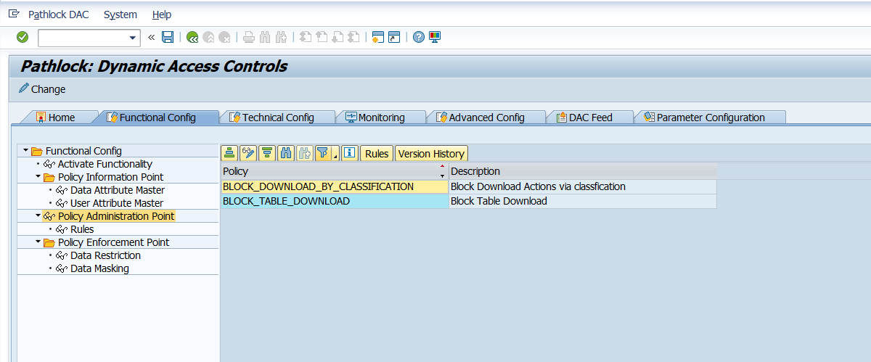
Sample policies created to test the Level 5 configuration.

6. Sample policy - classification-driven blocking
Recommended participant configuration. This is the main Level 5 story because it blocks based on the classification label, not only the table name.  Sample logic  Policy: BLOCK_DOWNLOAD_BY_CLASSIFICATION  IF download/export action is selected  AND classification is Restricted-PII or Internal-Financial  THEN deny access / block download | 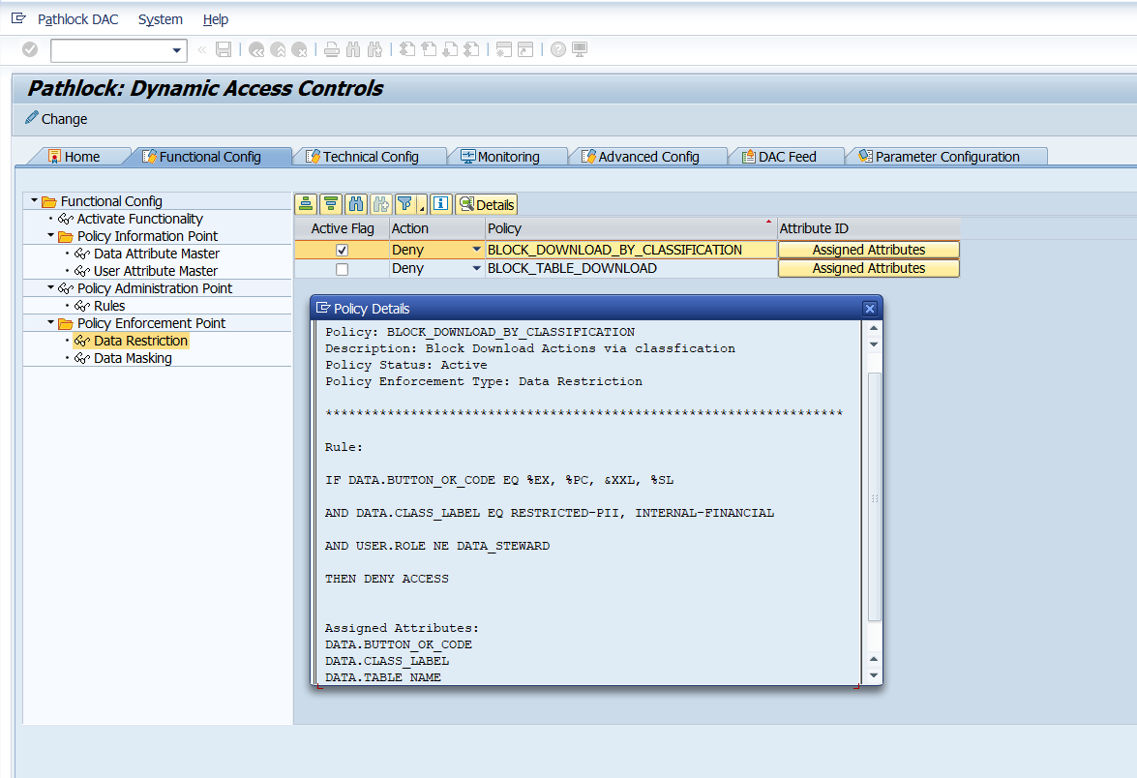  Primary policy with assigned attributes and rule conditions.

7. Optional reference policy - table-based blocking
Use this only for comparison or fallback testing. Keep it inactive during the classification-driven demo unless you intentionally want table-only logic.  Sample logic  Policy: BLOCK_TABLE_DOWNLOAD  IF download/export action is selected  AND table is SCUSTOM or SBOOK  THEN deny access / block download  If Public data is unexpectedly blocked, check whether this policy is active. | 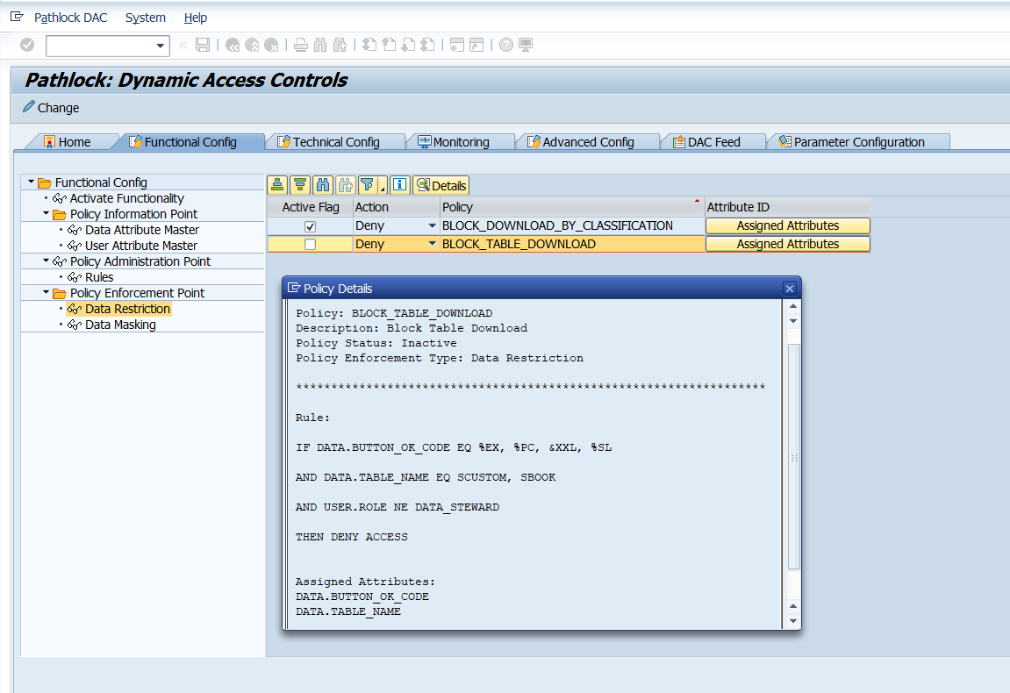  Reference policy for direct table-based blocking.

8. Test the use case
Ask participants to test the policy from SE16 using the same export buttons used during setup. Capture pass/fail quickly.
Test | Table | Classification | Expected result | Pass/Fail
1 | SCUSTOM | Restricted-PII | BLOCK | Pass
2 | SBOOK | Internal-Financial | BLOCK | Pass
3 | SCARR | Public | ALLOW | Pass

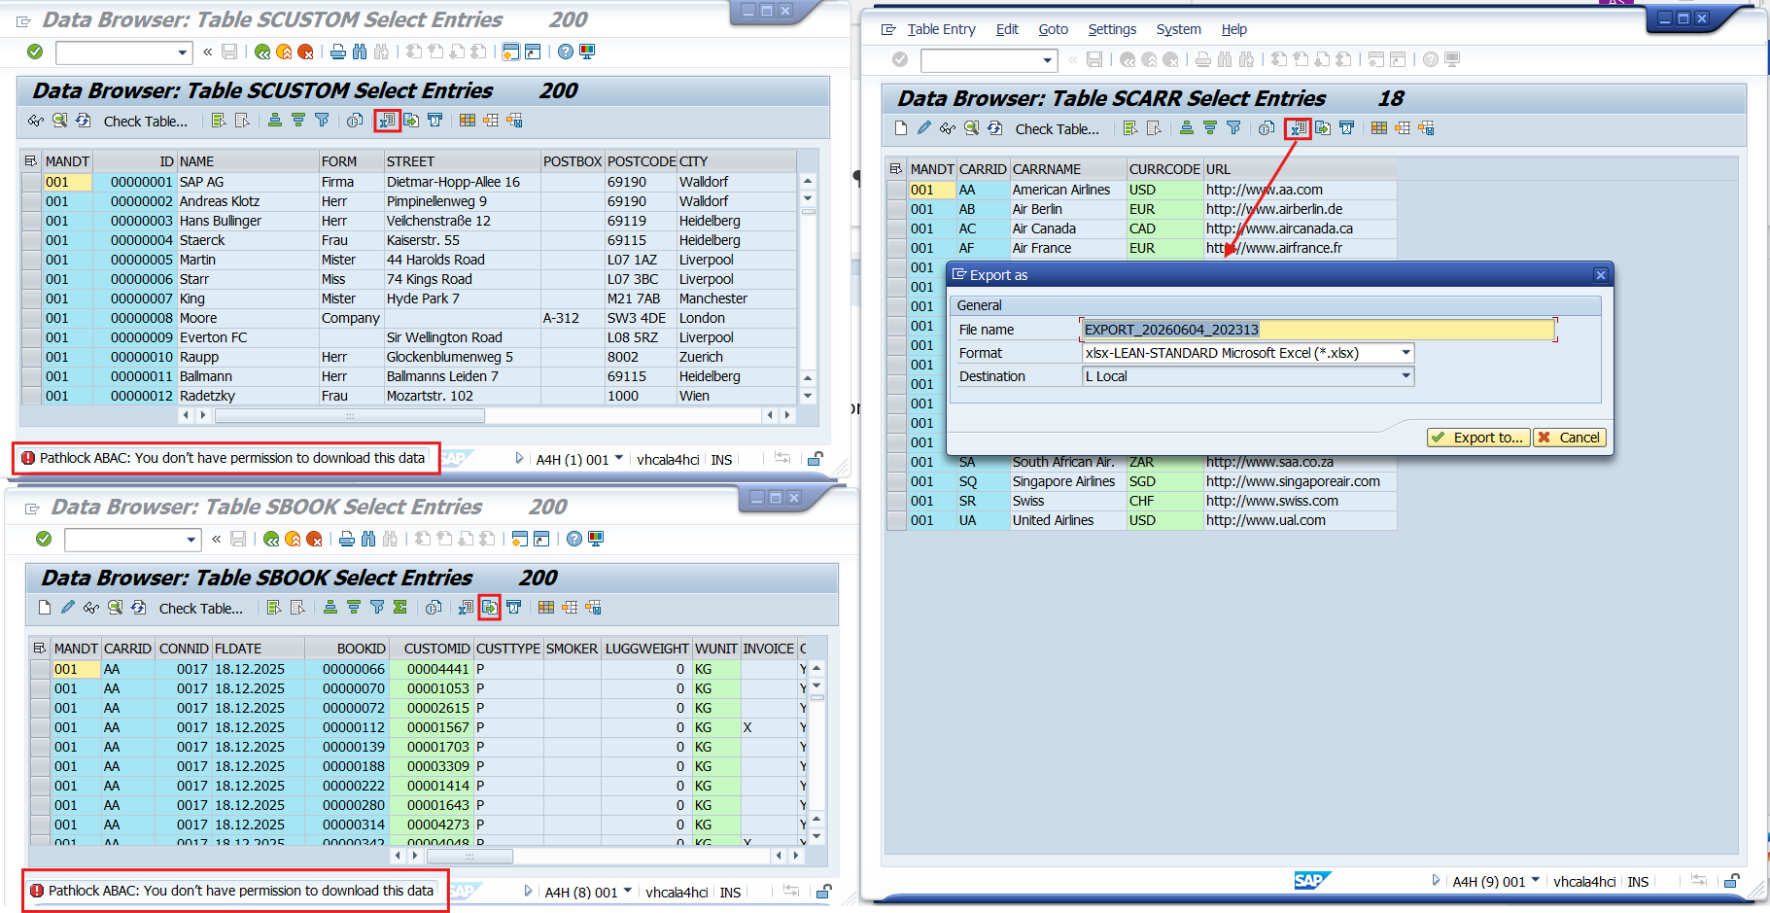
SE16 validation: sensitive tables are blocked while public data is allowed.

9. If something does not work
Use this simple checklist during the workshop. Do not deep-dive unless the same issue affects multiple participants.
Issue | Quick check
Sensitive table still downloads | Check BLOCK_DOWNLOAD_BY_CLASSIFICATION is active, assigned to Data Restriction, and has DATA.BUTTON_OK_CODE + DATA.CLASS_LABEL assigned.
Public table is blocked | Check BLOCK_TABLE_DOWNLOAD is inactive and SCARR is classified as Public.
No block message appears | Check enhancement ZENH_IMPL_BLOCK_DOWNLOAD is active in /APPSDM/CL_ACCESS_CONTROL=>PROCESS and message class zdac_worshop exists.
Policy does not evaluate | Check BADI /APPSDM/DATA_ATTRIBUTES and custom implementations ZBADI_BUTTON_OK_CODE / ZBADI_TABLE_NAME.
Wrong table behavior | Check /APPSDM/DC classification criteria for SCUSTOM, SBOOK, and SCARR.
SAP runtime dump occurs | Treat as system/Basis issue first. Check ST22, SM21, work process traces, memory/swap, and the enhancement logic.

Facilitator close  The main participant takeaway: classify the data, write one simple DAC policy, and validate block vs allow behavior. | Keep it simple  Avoid teaching the BADI and enhancement internals unless the audience asks or troubleshooting requires it.

